ALM connection selenium(32 bit):
- Open CMD as administrator, Change your directory to C:\Windows\System32
- OTAClient.dll is typically located in C drive ,
C:\Users\<username>\AppData\Local\HP\ALM-Client\localhost\
If you are unable to see The AppData folder, enable viewing of Hidden files as AppData is a Hidden Folder
For registering the dll, use the below command.
C:\Windows\System32>regsvr32.exe C:\Users\Administrator\AppData\Local\HP\ALM-Client\localhost\OTAClient.dll
Note: Succeeded message will be displayed
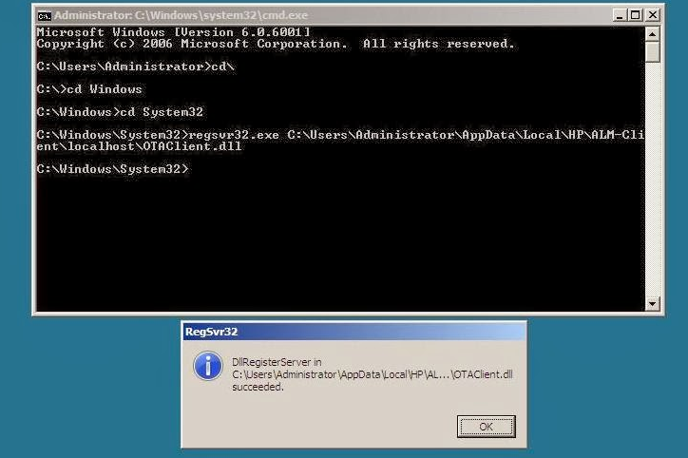
- Download Jacob-1.18-M2-x86 or latest one. Add the jacob-(version)-x86.dll file in your project Root Directory. Add Jacob jar file in buildpath
- Use the below code to load the DLL file.
System.setProperty("jacob.dll.path", "D:\\jacob-1.17-M2-x86.dll");
LibraryLoader.loadJacobLibrary();
- Download ALMservicewrapper and add jar file from it:
http://automationtestingutilities.blogspot.ae/p/blog-page_11.html
Download Links: Stable Version 2.0
Download the ALM Service Wrapper Project + Sample Project
- Download TDConnect.exe from ALM main page->Tools->HPALM connectivity tool
And Install it
- Run the below code in selenium to change the testcase status:
import com.jacob.com.LibraryLoader;
import atu.alm.wrapper.ALMServiceWrapper;
import atu.alm.wrapper.enums.StatusAs;

import atu.alm.wrapper.exceptions.ALMServiceException;

public class ALM_Integration {

public static void main(String[] args) throws InterruptedException, ALMServiceException

{
System.setProperty("jacob.dll.path", "D:\\Renuka\\Selinium\\Eclipse WS\\Learning\\SeliniumBasics\\jacob-1.18-x86.dll");
LibraryLoader.loadJacobLibrary();

ALMServiceWrapper wrapper = new ALMServiceWrapper("http://cusvqc01/qcbin/");
Thread.sleep(3000);

wrapper.connect("bc.renuka","Kulfi@01", "DUBAI_CUSTOMS_ITBUILD", "Coastal_Vessel_Management");
Thread.sleep(3000);
System.out.println("QC connected");

wrapper.updateResult("SIT_Release_1 - Cycle 3", "VES.MT.UC05", 1573, "test", StatusAs.FAILED);

}

